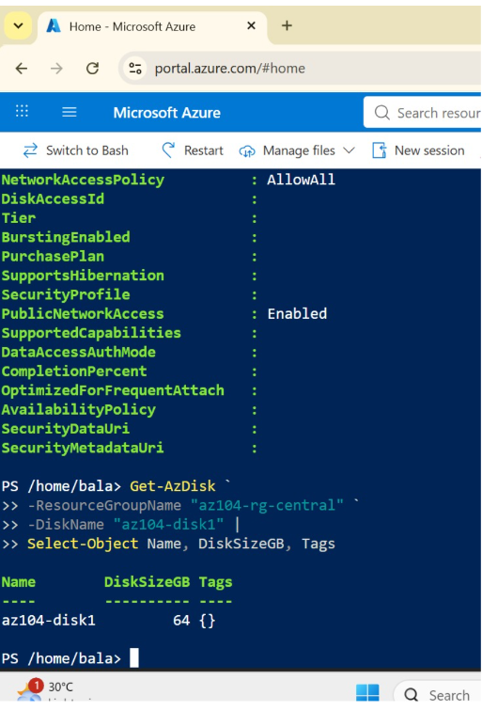
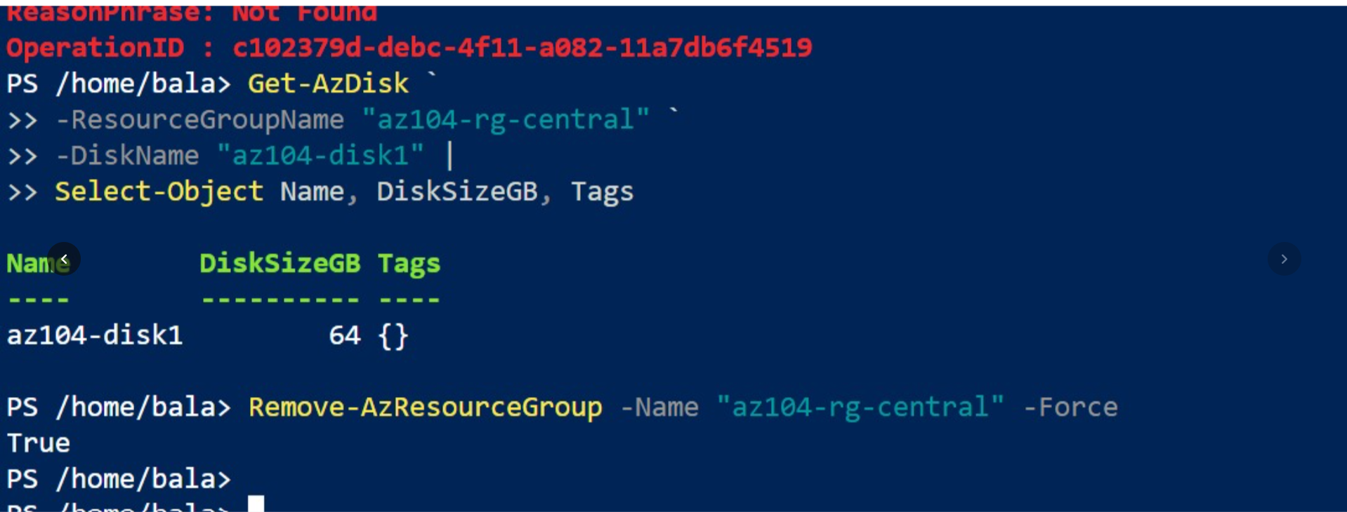
"For Task 1, I used Azure PowerShell in Cloud Shell to create and configure an Azure Managed Disk. The disk name is az104-disk1, and its size is 64 GB. I verified the disk using Get-AzDisk."
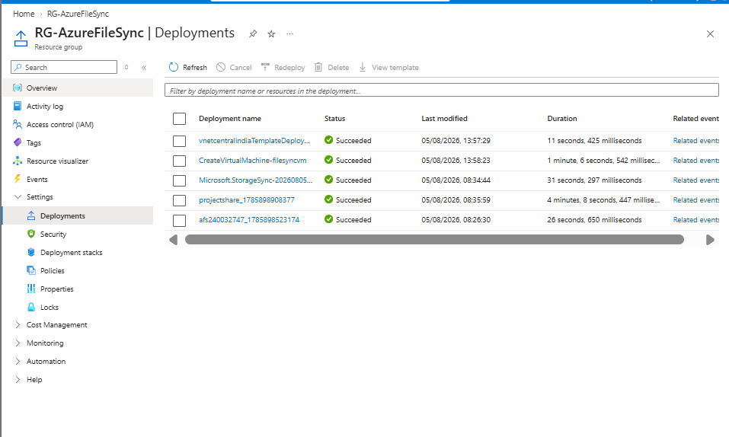
"For Task 3, I deployed Azure resources into the existing RG-AzureFileSync resource group. The deployment history shows multiple successful deployments, including the virtual machine, virtual network, Storage Sync Service and storage account."
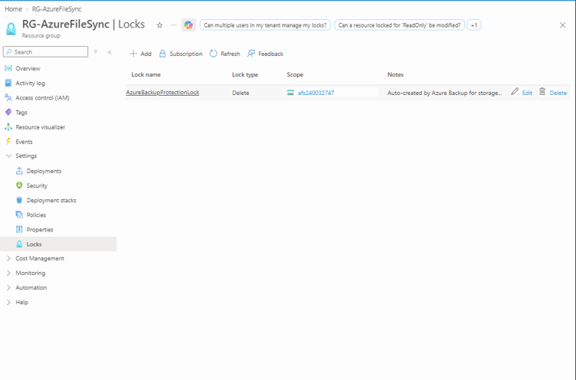
"This screenshot shows a Delete lock applied to the storage account. The lock is named AzureBackupProtectionLock and was automatically created by Azure Backup."
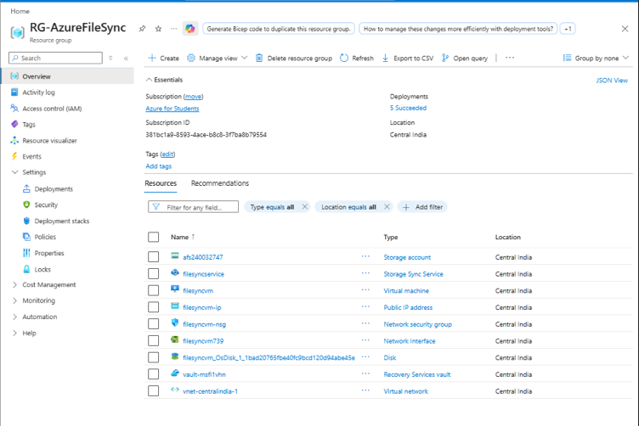
"This is the existing resource group where my Azure resources were deployed. The resource list shows the VM, VNet, storage account, network security group, public IP, network interface and other supporting resources."
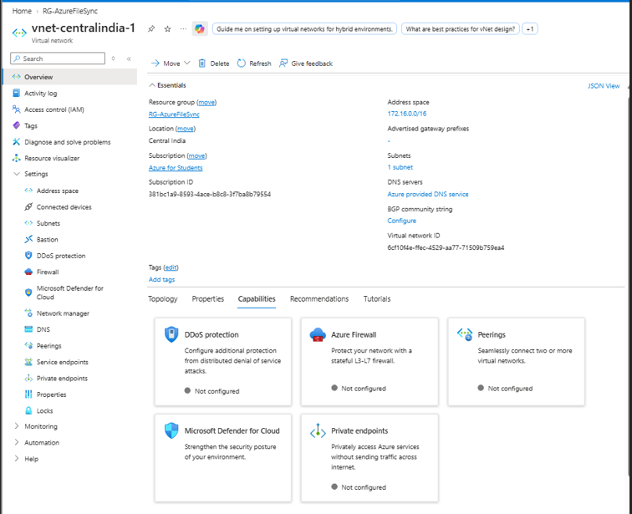
"For Task 4, I created and configured a Virtual Network named vnet-centralindia-1. Its address space is 172.16.0.0/16, and it contains one subnet. Azure-provided DNS is configured for name resolution."
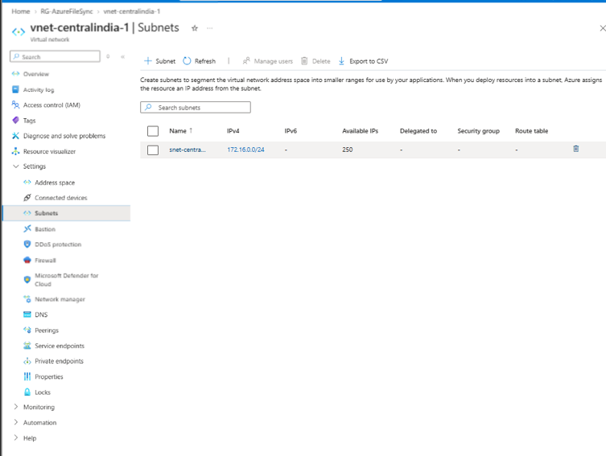
"I created a subnet named snet-centralindia-1 inside the virtual network. Its IPv4 address range is 172.16.0.0/24."
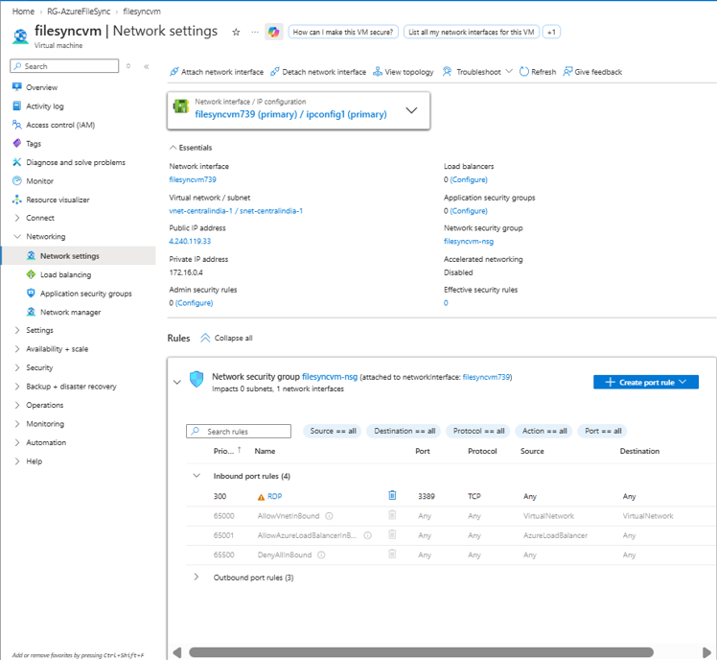
"I deployed the virtual machine into the VNet subnet. The VM has private IP 172.16.0.4 and public IP 4.240.119.33. I also associated the network interface with the Network Security Group filesyncvm-nsg, which contains the RDP rule on TCP port 3389."
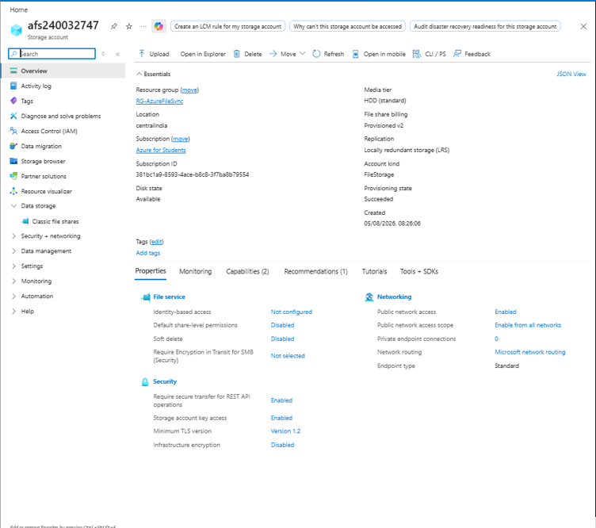
: I have the VM, Storage Account afs240032747, and Storage Sync Service deployed. The Storage Account is a FileStorage account using LRS replication. The screenshots document the storage configuration."

